
July monthly report
Project Title:
Conversion of post-combustion gas from cement manufacturing to syngas by electrochemical CO₂ capture and reduction
……..........................................................
Dr. Pongkarn Chakthranont
Sothearoth Heng
NCR ID: 803198
Under the supervision of
Dr. Pongkarn Chakthranont
Contract Number: NCR-NN-2023-20170-EN
July 2024

- Tasks list for July
- CO2RR performance under a diluted CO₂ condition:
  - Ni0.5-2D-NC (1.8mg/cm²)
  - Acid-treated Ni-2D-NC (1.8mg/cm²)
  - Ni-2D-NC(1.8mg/cm²) - CALF20 (2.5 and 0.5mg/cm²)
- CO2RR performance under an acidic media using cation exchange membrane (CEM) under diluted CO₂ and simulated flue gas (5%O₂, 15%CO₂, 80%N₂)
- Influence of introducing polyaniline (PANI) and 4-aminobutylphosphonic acid (P) additives in Ni0.5-2D-NC on CO2RR performance under diluted CO₂ and simulated flue gas (5%O₂, 15%CO₂, 80%N₂)
- Experimental Procedure
Preparation of the Ni-2D-NC-CALF20 cathode electrode via spray coating method
The as-prepared Ni-2D-NC-CALF20 catalyst was spray-coated onto Sigracet 39BB carbon paper. Briefly, 40mg of CALF20 powder was ultrasonically mixed with 160µL of Nafion ionomer and 20mL of ethanol. The as-prepared CALF20 solution was then sprayed behind the GDL to get a desired mass loading of 2.5mg/cm². 150 mg of the Ni-2D-NC and 381µL of 10% by catalyst weight of XA-9 binder were ultrasonically mixed with 10ml of IPA for 60 min to form a dark colloidal solution which was then sprayed onto the front side of the GDL with 0.5 ml/min on 95 °C hotplate to obtain ~ 0.18 ± 0.1 mg/cm².

Preparation of Ni-2D-NC@PANI and Ni-2D-NC@P cathode electrode
Briefly, Ni-2D-NC (150mg) and PANI (15, 50, and 75mg) were mixed in 15ml of IPA to make a dispersion solution. Subsequently, the dispersion solution was sonicated for 2h, followed by overnight stirring at a room temperature. Afterwards, 381µL of XA-9 binder was added into the dispersion solution and sonicated for another hour to make an ink solution. The ink solution was then sprayed onto the front side of GDL to get Ni-2D-NC@PANI. On the other hand, the Ni-2D-NC@P cathode was prepared in the same manner as Ni-2D-NC-PANI except using 4-aminobutylphosphonic acid as an additive.

Preparation of acid-treated Ni-2D-NC catalyst
200mg of Ni-2D-NC was added into a 50ml of 1M H₂SO₄ solution, followed by overnight stirring to leach out of the excess Ni metal. The acid-treated Ni-2D-NC was then filtered out and neutralized with DI water for several times. Afterwards, the acid-treated Ni-2D-NC was dried in an oven at 80°C for 6h.

Electrochemical CO2RR measurements
A 5 cm² MEA electrolyzer was used to evaluate the CO2RR performance under modulated operating conditions. The IrO_{x}/TiPt, AEM (X37-50 Grade RT, Dioxide Materials) or Nafion 117 membrane (CEM) or Bipolar membrane (BPM), and different cathode catalysts were employed as the anode, membrane, and cathode electrode, respectively. 50 ml of 0.5M KOH or K₂SO₄+H₂SO₄ were recirculated and used throughout the experiment as the anolyte at 8 ml/min. The humidified 15%CO₂/85%N₂ gas stream was introduced into the cathodic inlet under total flow rates of 100 ml/min. Meanwhile, the cathodic outlet was directly injected into an online gas-chromatography for gas products analysis.

- Results
CO2RR performance of Ni-SAC/CALF20 at varied CALF20 loadings under a 15%CO₂ condition
To further confirm the effect of catalyst mass loading and the surface-accessible CO₂ layer of CALF20, we conducted a CO2RR performance test using Ni-2D-NC with a mass loading of Ni-2D-NC (1.8 mg/cm²) with 2.5 and 5 mg/cm² CALF20 layer behind the GDL. The Ni-2D-NC/CALF20 catalyst exhibited poor CO selectivity with a massively high FE(H₂), which might be due to the higher thickness and humidity sensitive of CALF20 obstructing CO₂ access to the catalyst surface, thereby increasing HER activity.

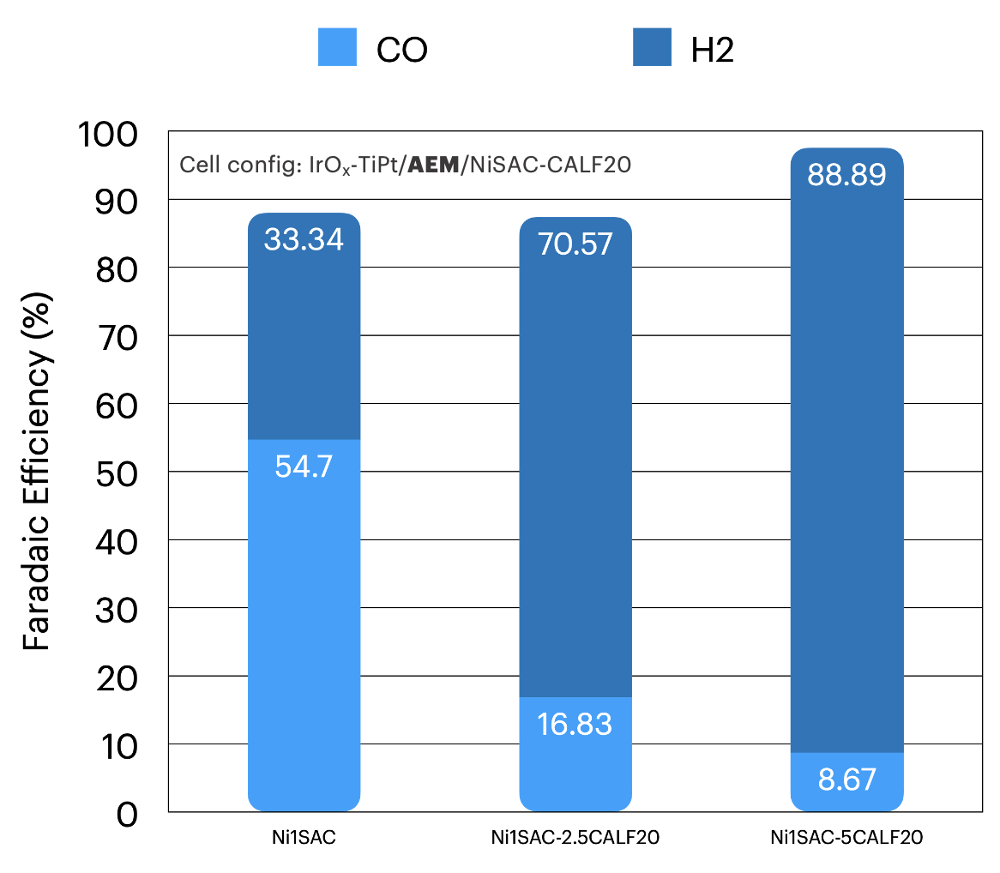
Figure 1. Faradaic efficiency of Ni-2D-NC/CALF20 with different CALF20 loadings under a diluted CO₂ condition at 200mA/cm²

CO2RR performance of different cathodes under a diluted 15%CO₂ condition
To further address the influence of Ni loading content on the catalyst performance, we conducted the CO2RR measurement of Ni-2D-NC with varied NiPc precursor content (0.5 and 1g) and acid treatment under a 15%CO₂/85%N₂ condition. As can be seen in Fig.2a, the Ni0.5-2D-NC catalyst showed the highest FE(CO) and stability with a FE(CO) of 70%, while Ni1-2D-NC and acid-treated Ni1-2D-NC suffered from higher HER activity due to flooding over time. These results indicated the importance of Ni content and species (Ni nanoparticles/cluster, metal, and excess unreacted Ni) that could potentially impact the catalyst performance. On the other hand, introducing another PANI additive into Ni-2D-NC catalyst led to decrease the catalyst performance, which might be attributed to the blockage of Ni active sites by PANI additive.
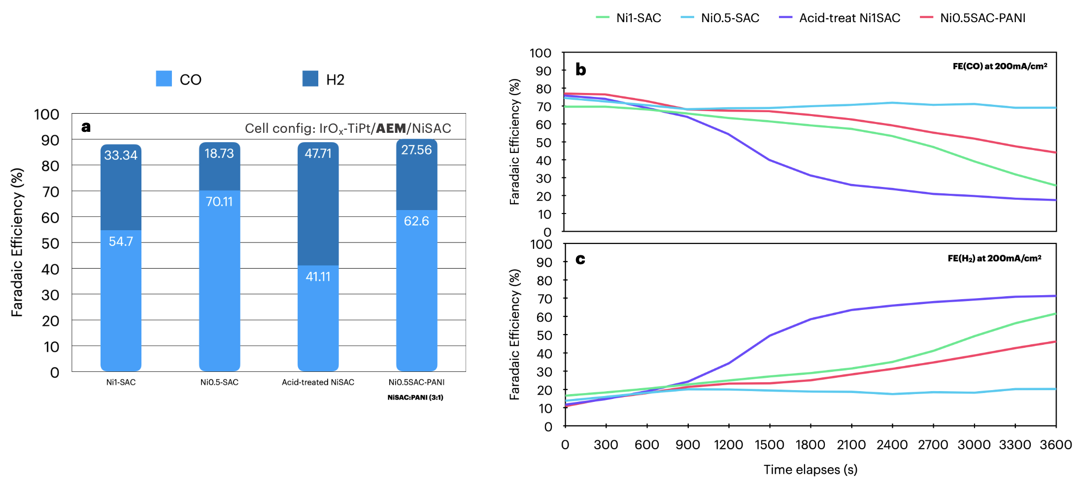
Figure 2. (a) Comparison of faradaic efficiency of different cathode materials and (b and c) faradaic efficiency of CO and H₂ as a function of time under a diluted CO₂ condition at 200mA/cm².

CO2RR performance of Ni0.5SAC cathode under an acidic media and pure CO₂ feed
According to several reports stated that the oxygen reduction reaction (ORR) can be suppressed under an acidic environment due to the free energy change of O₂ to *OOH intermediate requires a larger amount of energy compared to an alkaline condition.^{1,2} Before conducting the CO₂ reduction reaction under an acidic media with simulated flue gas, the Ni0.5-2D-NC cathode catalyst was primarily operated under an acidic media with pure CO₂ feed at different electrolyte pH of 1 and 3. As the pH decreases from 3 to 1, the FE(CO) moderately increases from 81% to 87% before a substantial decline at 1500s due to massive salt formation.³ These results demonstrated an excellent performance of Ni-.5-2D-NC catalyst even under a strong acidic environment. Meanwhile, In Fig. 4, the ORR activity was still dominant under acidic media of (K₂SO₄+H₂SO₄, pH = 3) and simulated flue gas condition, indicating a poor CO selectivity of the Ni0.5-2D-NC catalyst in the existence of Oxygen.
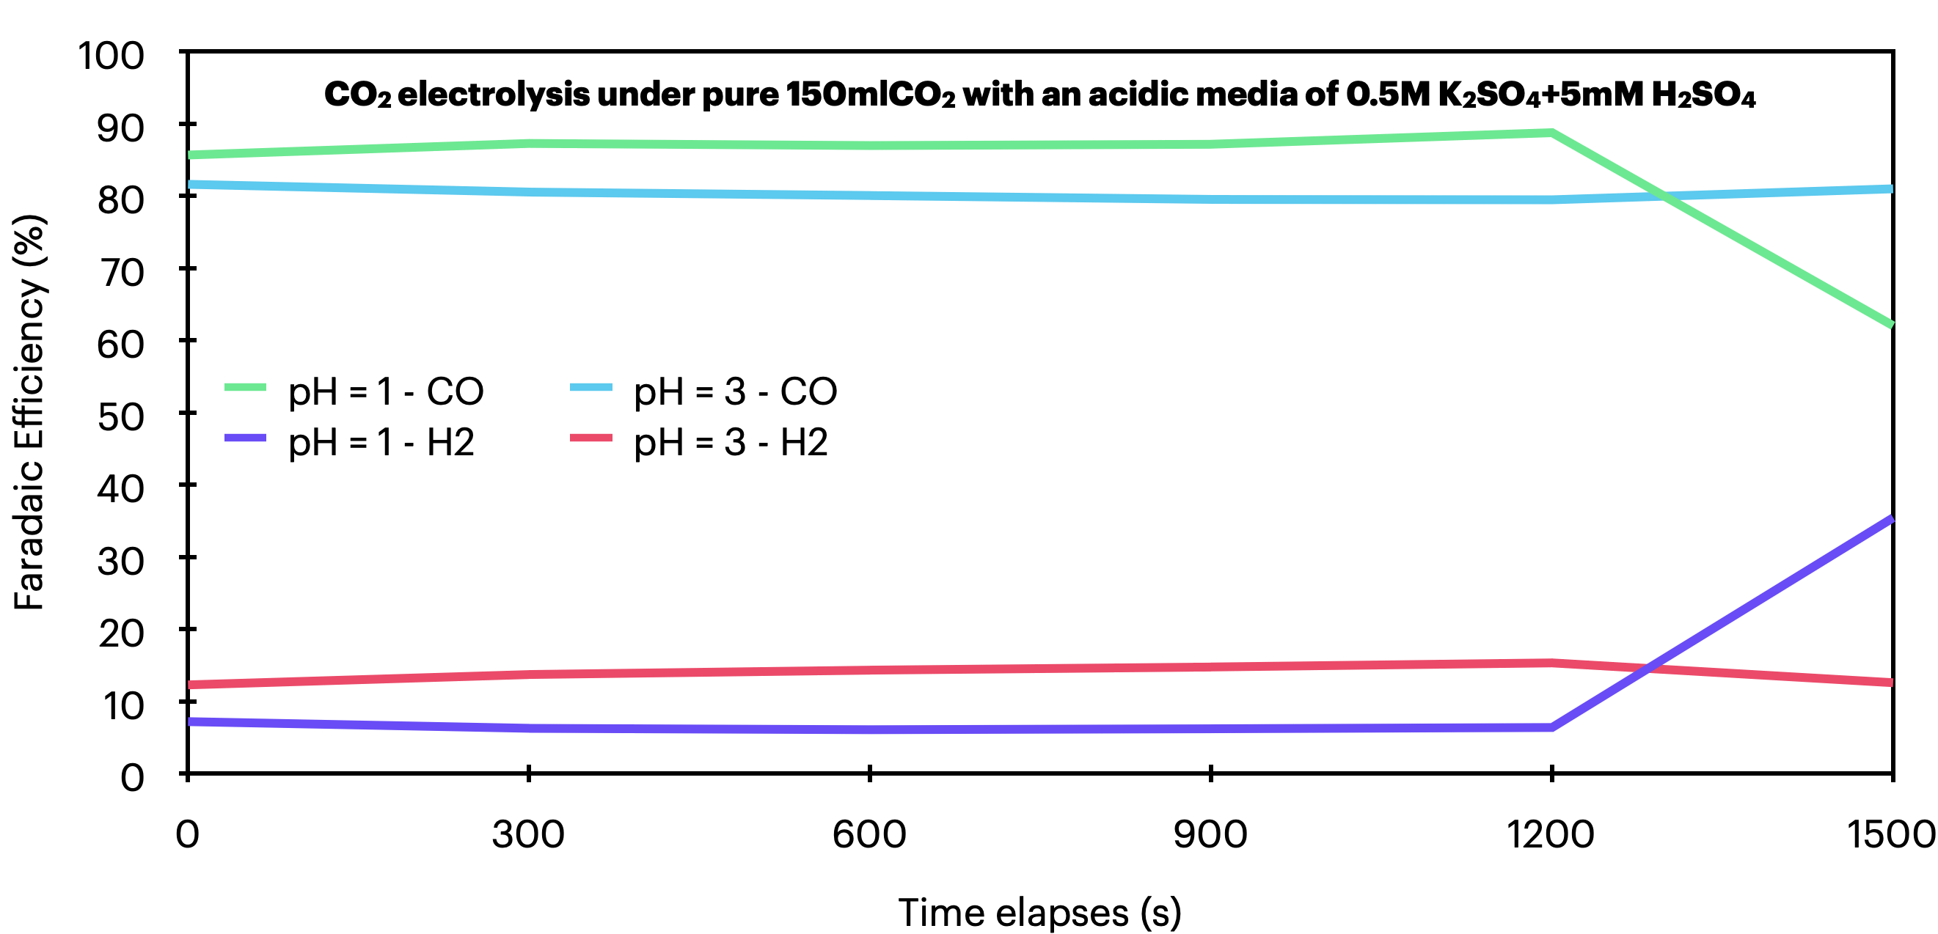
Figure 3. Faradaic efficiency of Ni0.5-2D-NC cathode as a function of time at different anolyte pH (1 and 3).

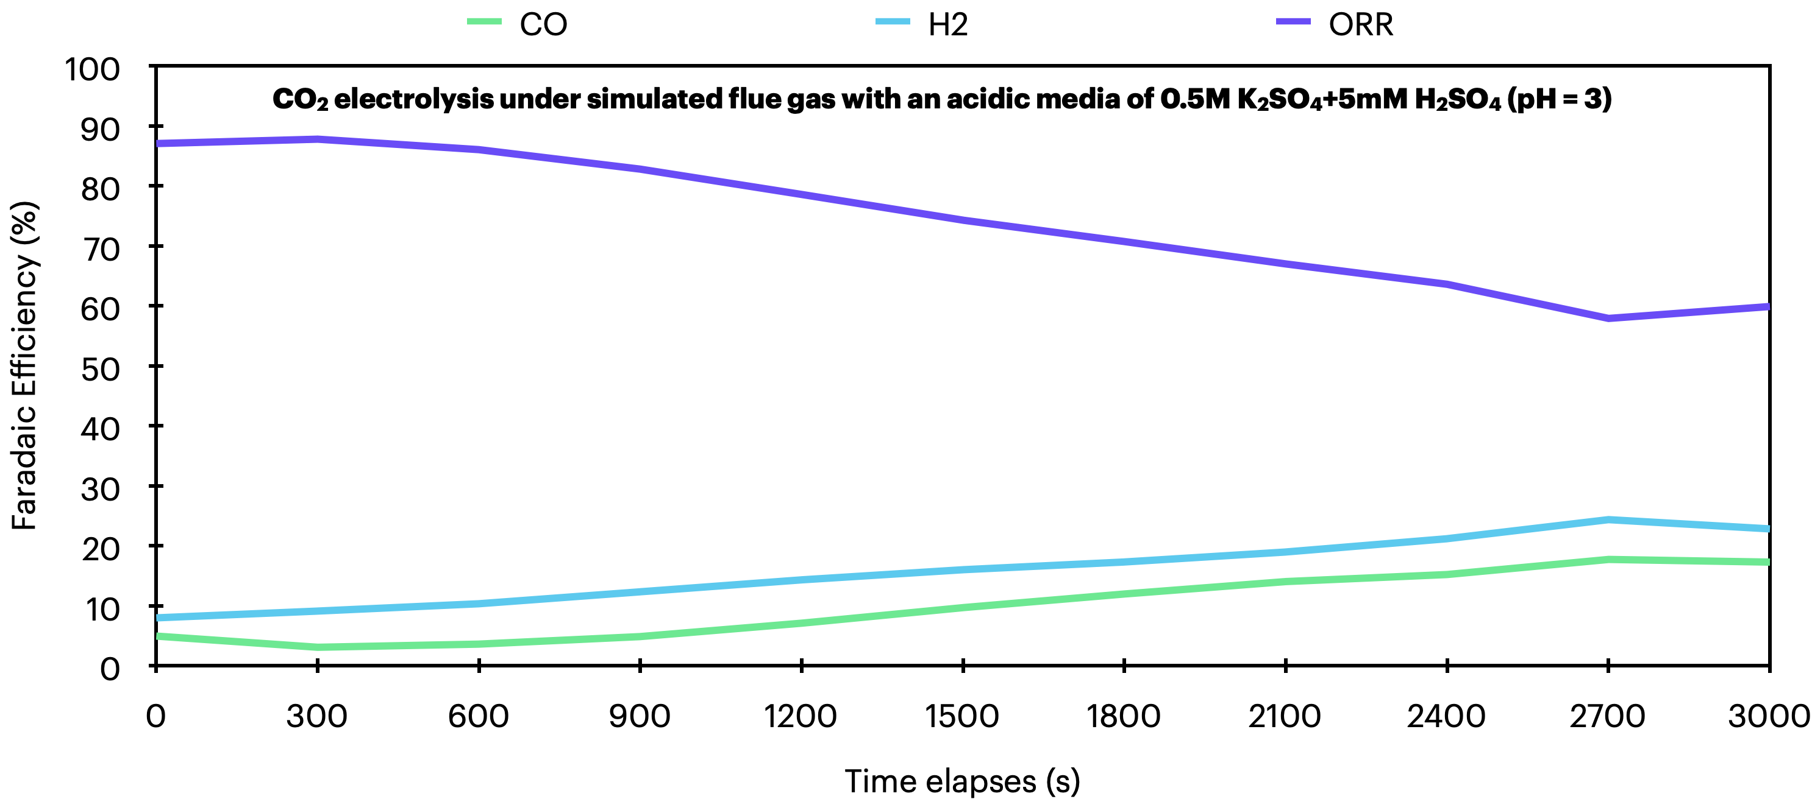
Figure 4. Faradaic efficiency of Ni0.5-2D-NC cathode as a function of time under a simulated flue gas.

Influence of introducing PANI and 4-aminobutylphosphonic acid additives in Ni0.5SAC on CO2RR under a diluted 15%CO2 condition and simulated flue gas
The introduction of polyaniline and phosphonic functional groups in the molecular catalyst was inspired by a few scientific reports due to its unique properties to inhibit the oxygen reduction reaction.^{2,4} The Ni0.5-2D-NC@PANI and Ni0.5-2D-NC@P catalysts were prepared and employed as cathode electrode with a Ni foam anode and bipolar membrane (BPM) for CO2RR under diluted CO₂ and simulated flue gas. As can be seen in Fig. 5, The CO2RR performance of both Ni0.5-2D-NC@PANI and Ni0.5-2D-NC@P showed identical results compared to a bare-Ni0.5-2D-NC with the FE(CO) of approx. 69 and 71%, indicating a minor improvement from introducing the additives to the Ni0.5-2D-NC catalyst. On the other hand, the CO2RR performance of both Ni0.5-2D-NC@PANI and Ni0.5-2D-NC@P was significantly suppressed due to ORR and HER activities becoming the dominant reactions.
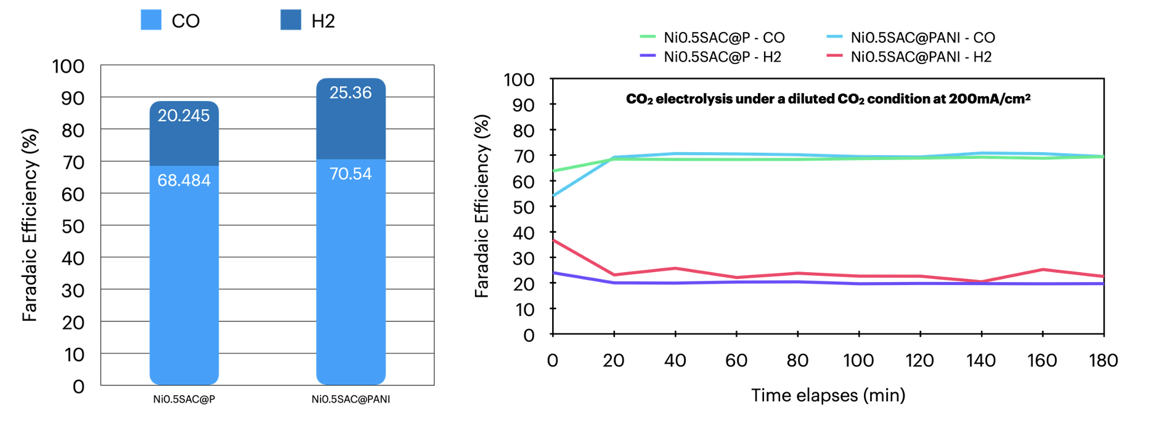
Figure 5. Faradaic efficiency of Ni0.5-2D-NC@P and Ni0.5-2D-NC@PANI under a diluted 15%CO₂
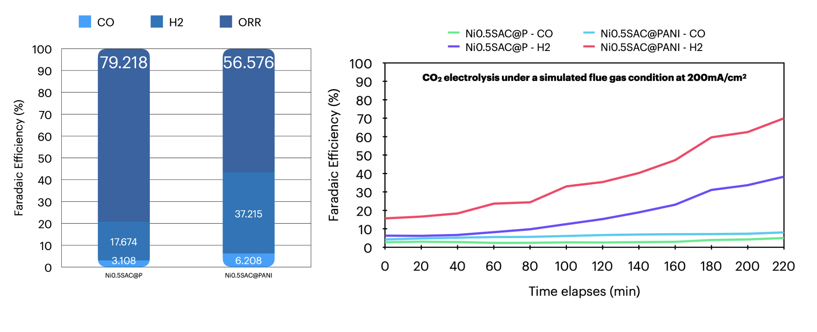
Figure 6. Faradaic efficiency of Ni0.5-2D-NC@P and Ni0.5-2D-NC@PANI under a simulated flue gas.

- Upcoming tasks
- Synthesis of Ni0.5-2D-NC catalyst
- Nano-engineering of the catalyst structure by modulating different precursors:
  - Thiourea
  - 3,5-diamino-1,2,4-triazole
- Catalyst modification by physical blending the Ni0.5-2D-NC with other additives and MOFs
- CO2RR performance measurement of modified catalysts under diluted CO₂ and simulated flue gas conditions

- References
1. Liu, L. Y. et al. Boosting oxygen-resistant CO2 electroreduction reaction in acidic media over conjugated frameworks. J Mater Chem A Mater 12, 9486–9493 (2024).
2. Wang, M. et al. Acidic media enables oxygen-tolerant electrosynthesis of multicarbon products from simulated flue gas. Nat Commun 15, (2024).
3. Li, H. et al. Tailoring acidic microenvironments for carbon-efficient CO2 electrolysis over a Ni–N–C catalyst in a membrane electrode assembly electrolyzer. Energy Environ Sci 16, 1502–1510 (2023).
4. Liu, Z., Yan, T., Shi, H., Pan, H. & Kang, P. Grafting amine-functionalized ligand layer on catalyst for electrochemical CO2 capture and utilization. Appl Catal B 343, (2024).

